Order Of Service

Singing: Psalm 72—CW page 93

Reading: Psalm 134

Opening Hymn: TLH 1

Reading: James 3:13-18

Request Hymn: CW Supplement 728

Reading: Luke 19:28-44

Sermon Hymn: TLH 17

Sermon Text: Song Of Solomon 1:17

Our House & Our Rafters

Prayer

The Apostles’ Creed, TLH page 12

Holy Communion

The Lord's Prayer

The Blessing

Closing Hymn: TLH 46

* * * * * * * * * * *

Bible Study: Lambs: I Kings 17:8-16; Meal In A Barrel
Sheep: Proverbs 5:15-19


He Made The Stars Also—Genesis 1:16

Water
Of
Life

11 October 2015

W A T E R O F L I F E

Independent Christian Church—Conservative Lutheran Doctrine

Worship Service: 9:30 a.m. Bible Study: 10:45 a.m.

Larry Cooper, Pastor E-Mail address:
111 N. Ridge Road lcooper@wateroflife.cc
Coon Valley, WI 54623 Web Site:
Phone: (608) 452-2105 www.wateroflife.cc

* * * * * * * * * * * * * * * * * * * * * * * * * * *

Sermon Text: Song Of Solomon 1:17

Our House & Our Rafters

* * * * * * * * * * * * * * * * * * * * * * * * * * *

17. The beams of our house are cedar, and our rafters of fir.

Cedar of Lebanon

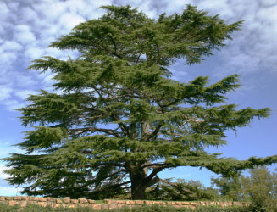
Cedar & Fir Trees

It is interesting, and extremely instructive, that Cedar and Fir Trees are mentioned here in the final verse of Song of Solomon 1. And both are mentioned in connection with the House, which is the dwelling place of the Bridegroom and His Bride!

Both the Cedar and Fir Trees were used in the construction of what we generally call Solomon’s Temple. Hiram the king of Tyre furnished Solomon with cedar trees and fir trees, and with gold, according to all his desire. I Kings 9:11.

Of special meaning here are the words of our Lord Jesus in John 14:1-3. “Let not your heart be troubled . . . In my Father’s house are many mansions . . . I go to prepare a place for you . . . I will come again, and receive you unto myself; that where I am, there ye may be also.” Let us pray for the guidance of the Holy Spirit as we ponder this final verse of Song of Solomon chapter one—a verse which is comforting beyond words.

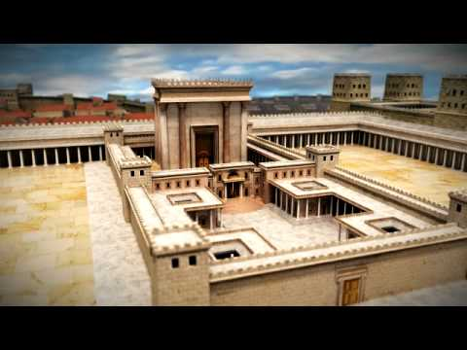

Solomon’s Temple

